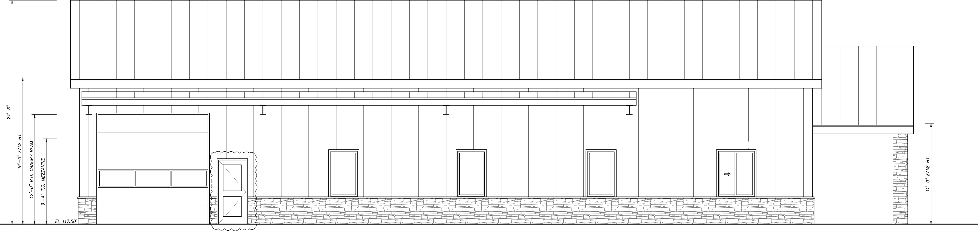

SERVICE WINDOW

*LEFTELEVATION*

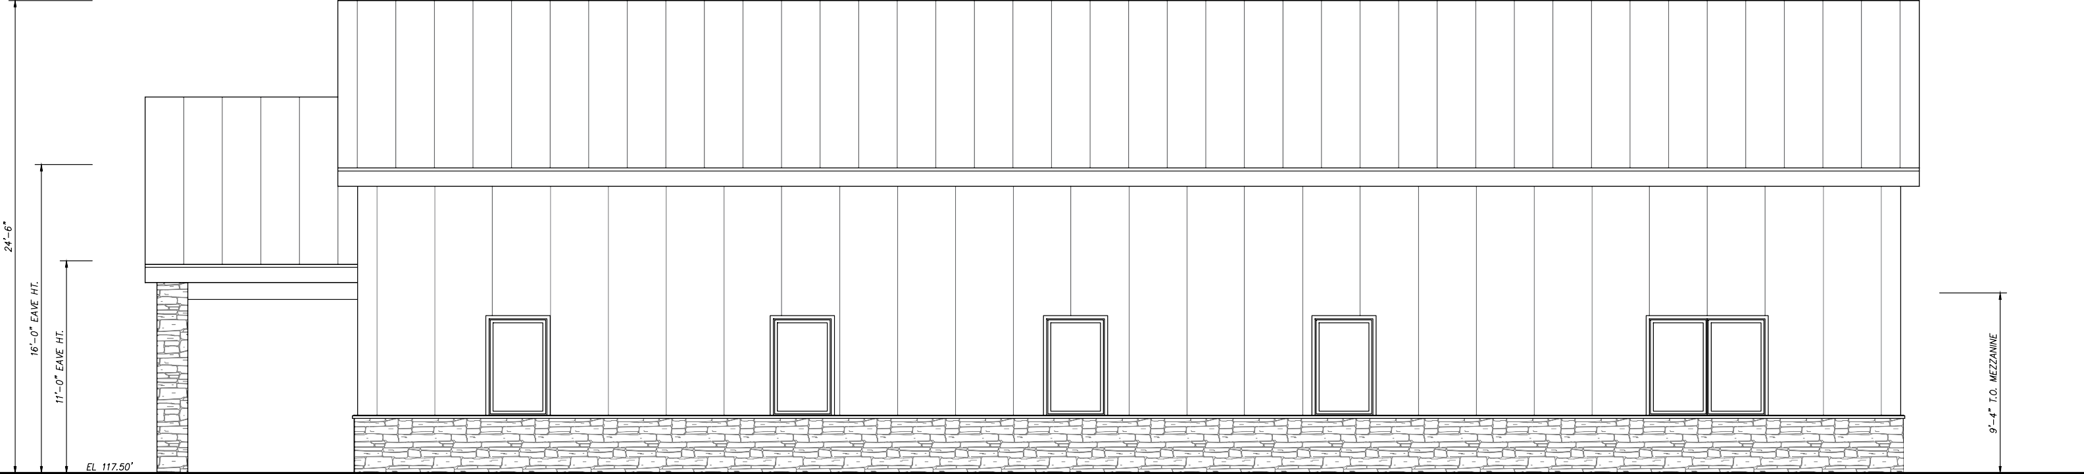

RANSONE'S LANDSCAPING

*RIGHTELEVATION*